Solution Architecture
Project: Emotion-Aware Personalized Learning Platform using BiLSTM, BERT & Gemini AI

1. Architecture Diagram
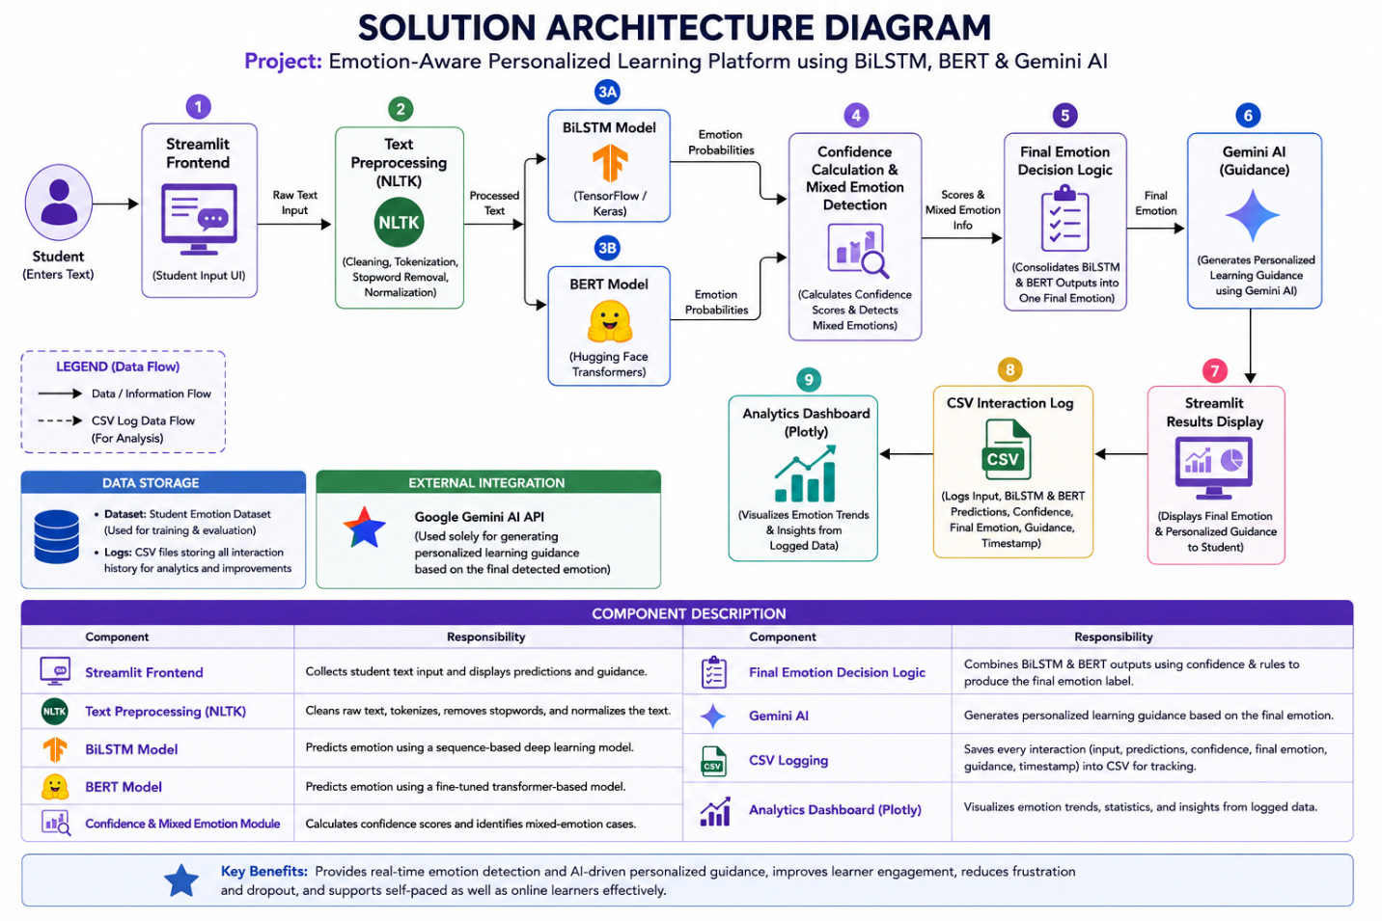

2. Component Description
Component | Responsibility
Streamlit Frontend | Collects student text input and displays predictions and guidance
Text Preprocessing (NLTK) | Cleans and tokenizes raw input text
BiLSTM Model | Predicts emotion using a sequence-based deep learning model
BERT Model | Predicts emotion using a fine-tuned transformer model
Confidence & Mixed Emotion Module | Calculates confidence scores and identifies mixed-emotion cases
Final Emotion Decision Logic | Consolidates BiLSTM and BERT outputs into one final label
Gemini AI | Generates personalized learning guidance from the final emotion
CSV Logging | Persists every interaction for history and analytics
Analytics Dashboard (Plotly) | Visualizes emotion trends from logged data

3. Data Storage
- Dataset: Student Emotion Dataset (used for training/evaluation)
- Logs: CSV files storing interaction history (input, predictions, confidence, final emotion, guidance)

4. External Integration
- Google Gemini AI API — used solely for generating personalized guidance text based on the final detected emotion.

